**HTML & Website Design**

**Project Group Process Workbook**

**2015**



|  |
| --- |
| Carl Moylan 15014355 |
| Vladislavs Vasiljevs 15493322 |
| Rafal Konarzewski 15019535 |

## Template 1 Roles & Responsibilities

**Roles & Responsabilities**



In order for the group to work effectively it is necessary for members to take responsibility for specific tasks. Assign a group member to each of the roles. If a group member is not performing their role this must be managed within the group. If this cannot be addressed within the group please contact one of your Project lecturers as soon as possible.

|  |  |  |
| --- | --- | --- |
| Role | Responsibility | Team Member |
| Project manager | Ensures each member remains on task and that meeting times are used appropriately and efficiently to produce the desired result. All team members will plan and prepare the website before building. Coding, working on the booklet and testing the final site before and after deployment will be done by all members. | Carl Moylan |
| Coder 1 | Vlad has taken the responsibility to configure images on the website that will meet industry standards and adhere to strict guidelines set during our meetings whilst using HTML5 All team members will plan and prepare the website before building. Coding, working on the booklet and testing the final site before and after deployment will be done by all members. | Vladislavs Vasiljevs |
| Coder 2 | Rafal will ensure that all code is re checked for validating.All team members will plan and prepare the website before building. Coding, working on the booklet and testing the final site before and after deployment will be done by all members. | Rafal Konarzewski |

## Every member of the team will fulfil several roles as they present themselves and we have agreed that help will be given freely to each other as needed. Outside help may also be sought from IT Support members who have already agreed to guide us in areas that we may not be sufficiently competent in as yet.Template 2 Understanding the Problem



**INTERPRET THE PROBLEM**

Using the headings below, discuss the details of the assignment amongst group members and fill out the template.

|  |
| --- |
| 1. Define the problem. What are you being asked to do? Do you fully understand what has to be delivered when complete?   **What are you being asked to do?**  Create a holiday company website for Flying Mangoes Holidays.  Showcase Showcase special deals and extraong mangoes holidays aimed at students and the budget market that may also appeal to a variety of other clients including staff of educational institutions that will be aware of the service.  The ability to book holidays online will be provided by a PayPal link that leads to the main PayPal webpage and not an actual booking link due to the constraints of this college project.  The site will have a contact form to ensure client satisfaction with the service offered.  A minimum of a 4 pages website has been requested and our team has decided on an 11 page site but will exclude specific pages that would be included in a professional website such as ‘terms of business’ and other legal requirements as we feel this is outside our current educational parameters.  And a clearly defined, consistent, navigation system.  The site must be deployed to the cloud and be available for online surfing and search engine optimised by correct use of the <title> tag and the use of <meta> tag. |
| 1. **List the different XHTML concepts & Web design considerations that you believe will need to be understood in order to complete this assignment.**   We will use CSS 3 to layout and design elements of the website to help make the website look consistent and aesthetically pleasing.  drop down menu for our navigation bar  We will use HTML 5 to structure the content and we will use JavaScript for widgets/gadgets to make the website more dynamic and user friendly.  We, as a team, until recently had no knowledge of JavaScript but we are willing and able to research in advance to attempt to include these dynamic elements. Also we will work on JavaScript as a team to be able to finish our JS code  We will use CSS 3 animations which will allow us to have image sliders without using JS.  We are going to used @media in CSS to make the website responsive to other resolutions. Example mobile phones.  We will have a login page, what will be have fake login features, written In JavaScript. It will have pre made passwords and username, also if the password or the username is written wrong or doesn’t exist, after three turns you will be blocked from trying login again.  Registration page, will be build, where users will be asked to input their names, date of birth and more information and fields will be validated with JavaScript.  We will have a booking form, again validated with JS. Will ask all the general questions. |
| 1. **What approach will be taken to implement the website e.g. CSS/tables? Explain your reasons for decisions taken.**   Before coding we will draw on paper how we want the layout etc. Once we have decided on the layout. We as a team will code the layout off the website first, things like wrapper, header, footer, drop down navigation bar, image slider. Each member off the team will take sections off the fixed main layout and work on it. But not alone but with other team members if any issues occur. To help the work flow move faster and also will mean that every member off the team had some contribution to the whole webpage and not just few parts. |
| 1. **What has been your Group’s strategy for validating your code? How have you approached this?**   We will use the following websites, to validate our code, <http://vadlidator.w3.org/> for HTML 5 and <http://jigsaw.w3.org/css-validator/> for CSS 3.  When coding we decided to validate our code by sections. So ever section we code we will validate, this helped us maintain the code from getting many errors when it came to final validation  At the end we will have 11 pages to validate, each member will have to validate 3-4 pages each at least. Once again if someone is stuck in validating, team members will help each other. |

## Understanding the Problem



**Project requirements**

List the requirements that you have for your website

|  |
| --- |
| 1. What is the overall goal of your website?   The goal for our website is to sell holidays online to the target market specified by our client.  Potential clients should be able to use their credit card to book a holiday.  The website will provide a professional service that will encourage repeat bookings.  There should be no legal implications that may cost the company financial stress.  Our goal is to have a nice looking website, with colours we have picked, which are, very dark grey, white and bright orange. These colours are our three mean colours for our website.  We also want to have an image slider on the top off the website and it should be the width off the wrapper.  After the image slider, we want to have a drop down navigation bar. On the left side off the wrapper, we will have a website logo and below it there will be date and time displayed that is written in JS.  On the very top off the website on the left side. We will have two buttons, once will have a login page and the other will be a register page.  Inside the login page, you will be able to input username and password and you will have 3 tries before you get blocked from inputting username and password.  On the register page you will be able to input your name and any other information, register on our website.  In the middle off the page, we will have an image slider that will three images off the holiday. We also have information about the holiday and book now button and also a heading that will be the title off the holiday.  On the very bottom of the website, on the footer. On the left we will have address and email, in the middle off the footer we will have social media icons, google plus and twitter that will be linked to our accounts and finally on the right side, we will have a section to credit all off the members of the team.  Also we will have a booking form, where you will be able to pick the date you want to book your holiday on, also will ask some basic questions. |
| 1. What are the functional requirements for your site? What will the site **do**?  * A deposit will be paid on all bookings and is non-refundable. * Final payment shall be one month in advance of departure and after this date there will not be a refund offered. * Clients will be notified of their obligation to arrange Travel Insurance without prejudice to the company. |

|  |
| --- |
| 1. What are the non-functional requirements of your site? Do you have a preference for the look and feel of the site?  * Aesthetically pleasing. * Easy to navigate (as requested by our client). * A page should not take more than 2 seconds to load. * Reliable service provider. (Website not going down for more than a few minutes). This will be adhered to within the constraints of free web providers that will be used to go-live. * There may be constraints within this project that may not be strictly adhered to due to the requests made upon us as a team and we are dedicated to overcome these issues wherever possible without having to pay € to complete this project. * Realising that it will be important to locate the most essential information at the left or top of the homepage we opted for the top providing a navigation bar that can lead to any area of the website. (*Basics of Website design for accessibility*, 1996) According to studygds.net it is essential to locate ‘Logos, menus and features consistently and predictably’ (*Basics of Website design for accessibility*, 1996) ) which we have taken into account and adhered to. |
| 1. What other requirements do you want to achieve in your site?   We wish to promote Flying Mangoes as a recognizable brand without prejudice to existing companies that may use this brand name.  We wish to target both males and females from late teens to middle age living in Ireland.  Affordable holidays for people with low disposable income.  Our target audience will be computer literate and possibly use the web on a regular basis. |

## Template 3 Exploring Ideas

## Exploring ideas – What will the user interface look like?

Discuss possible designs for your website. Once the group decides on a design use Microsoft Word or a Balsamique Mockup to demonstrate the chosen design and layout of website.

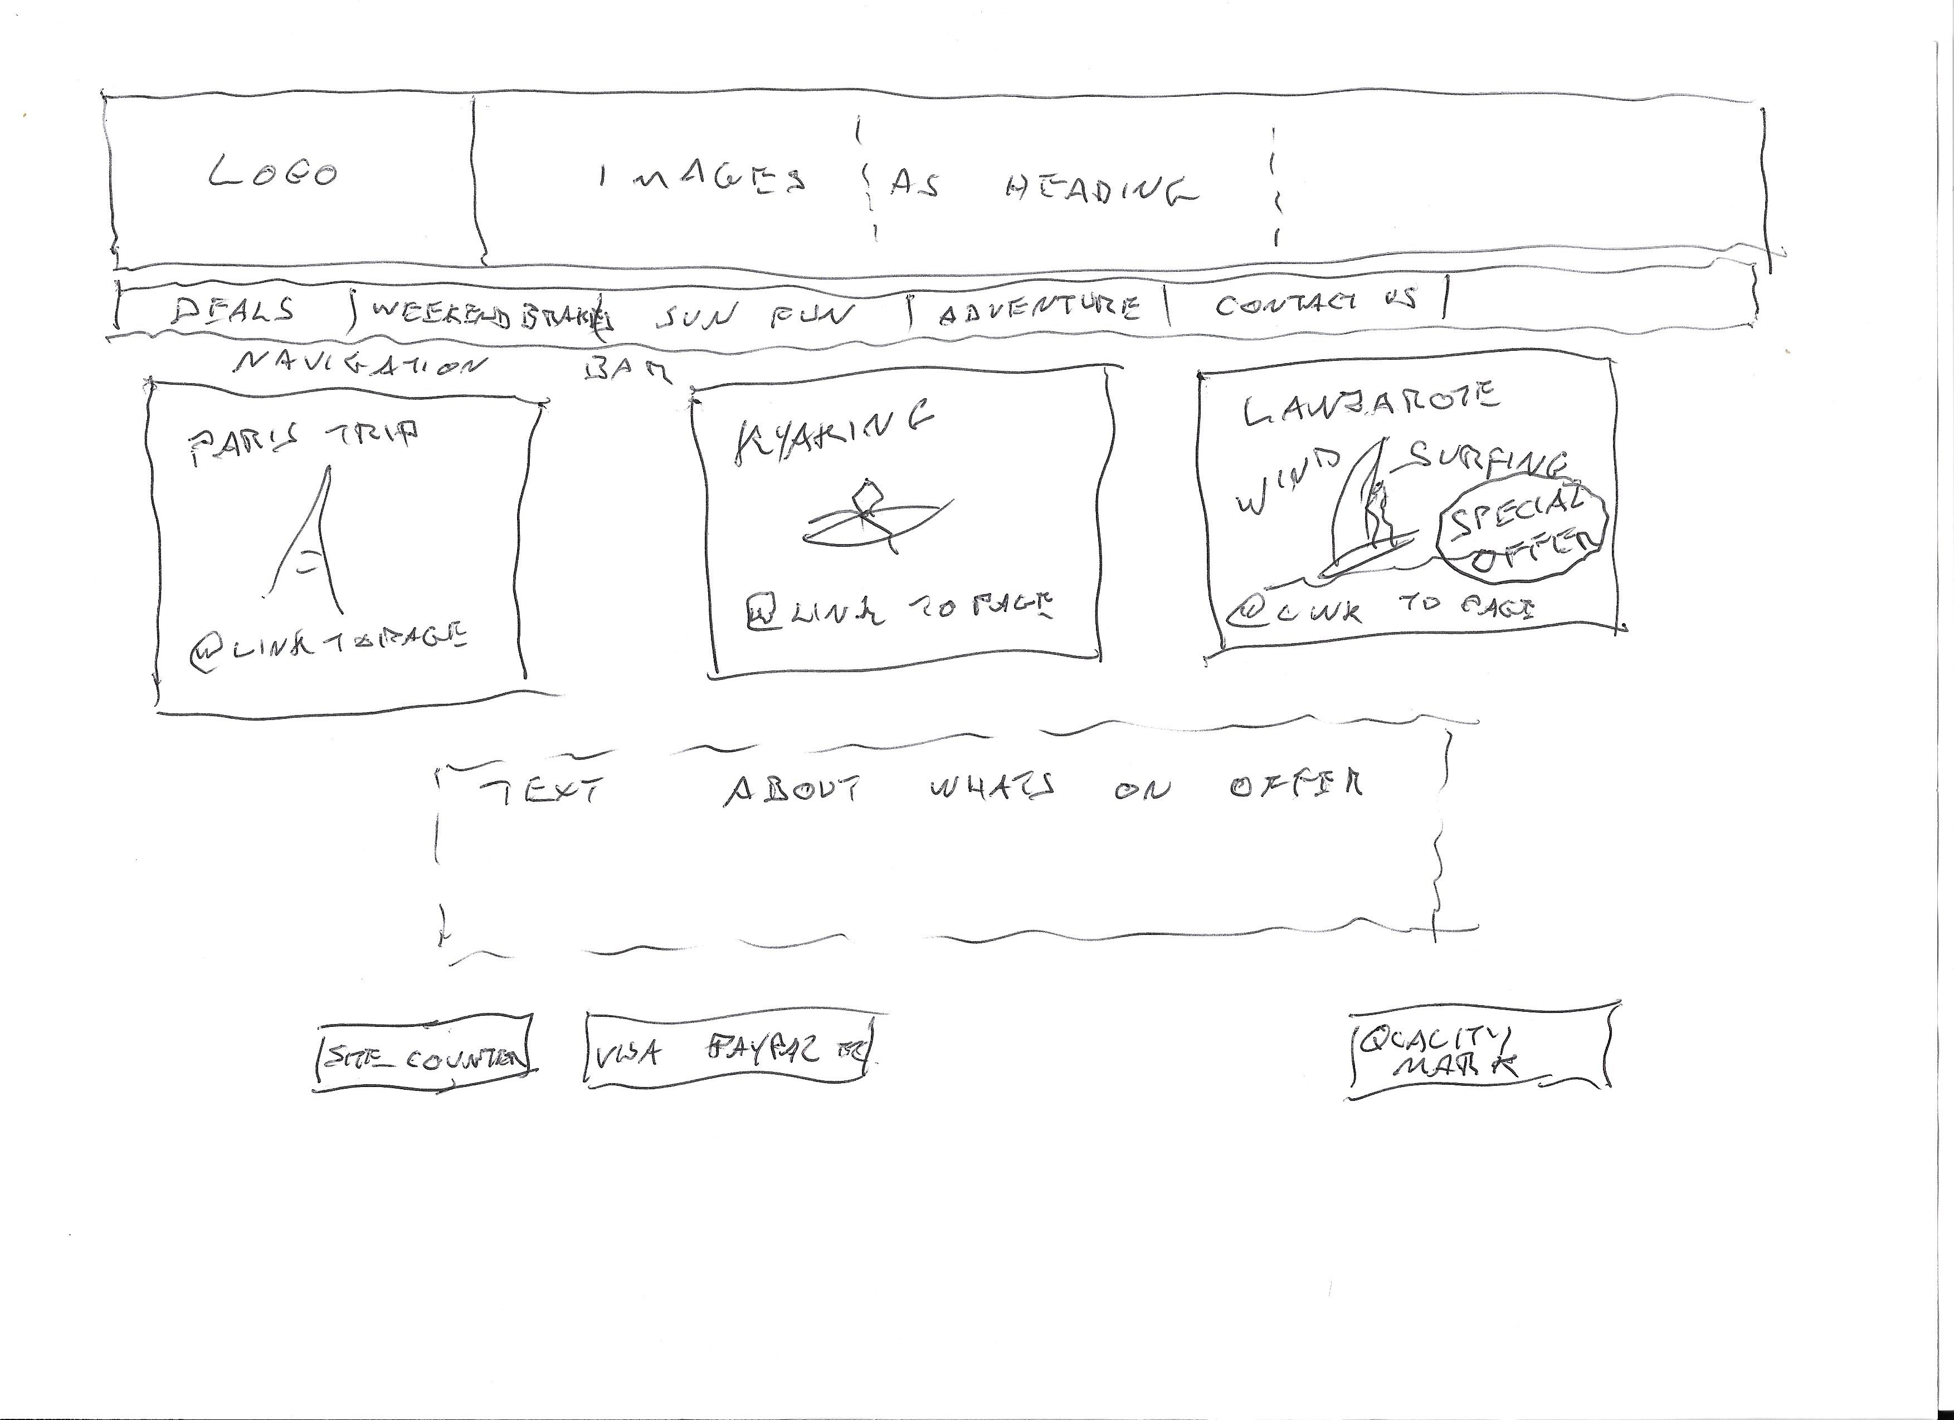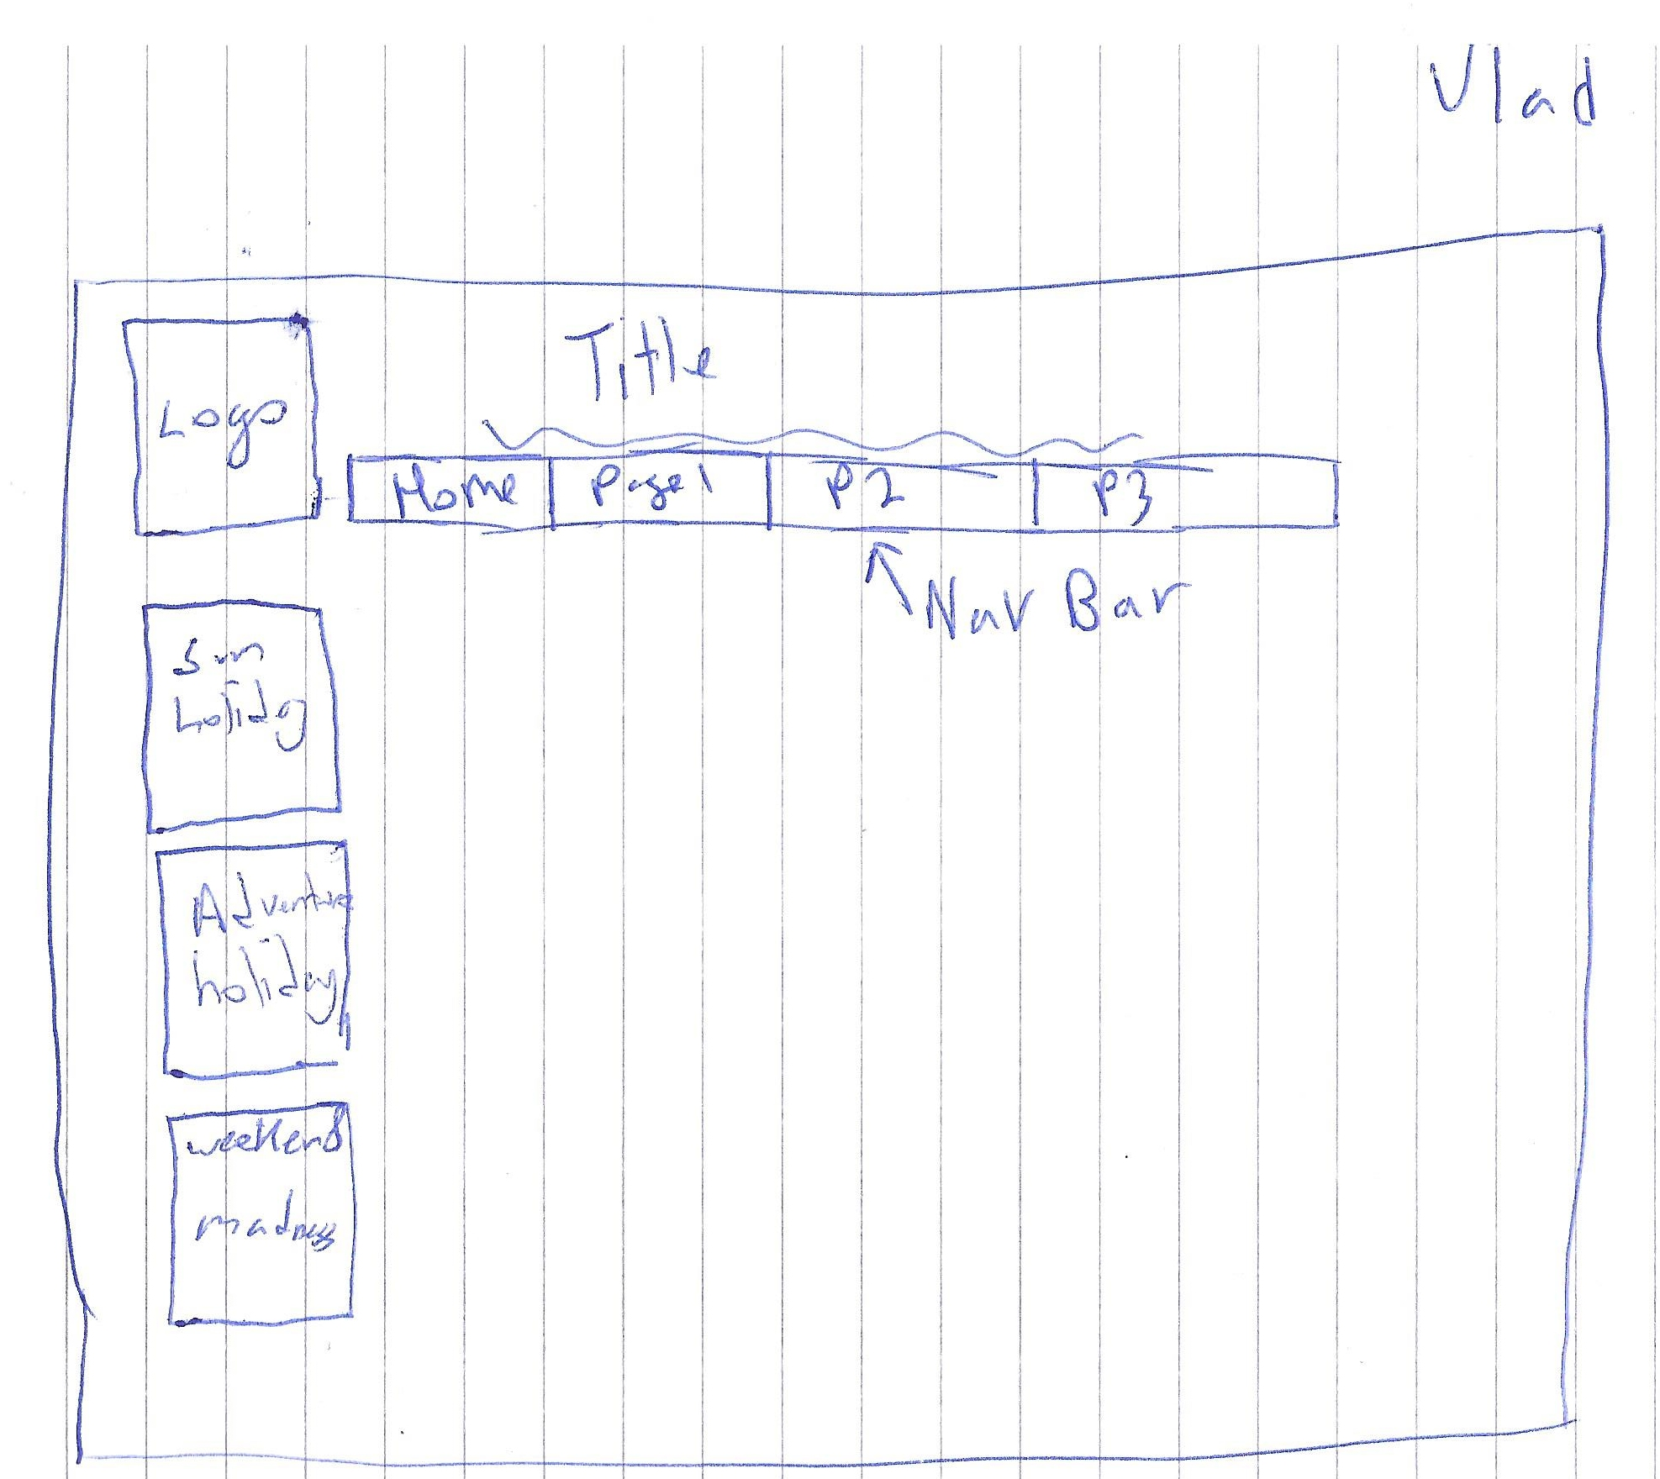

## Exploring Ideas

## Exploring ideas – What will the user interface look like?

**Include Wireframes here**

This was a particularly useful image shared by Vlad which helped in our design.

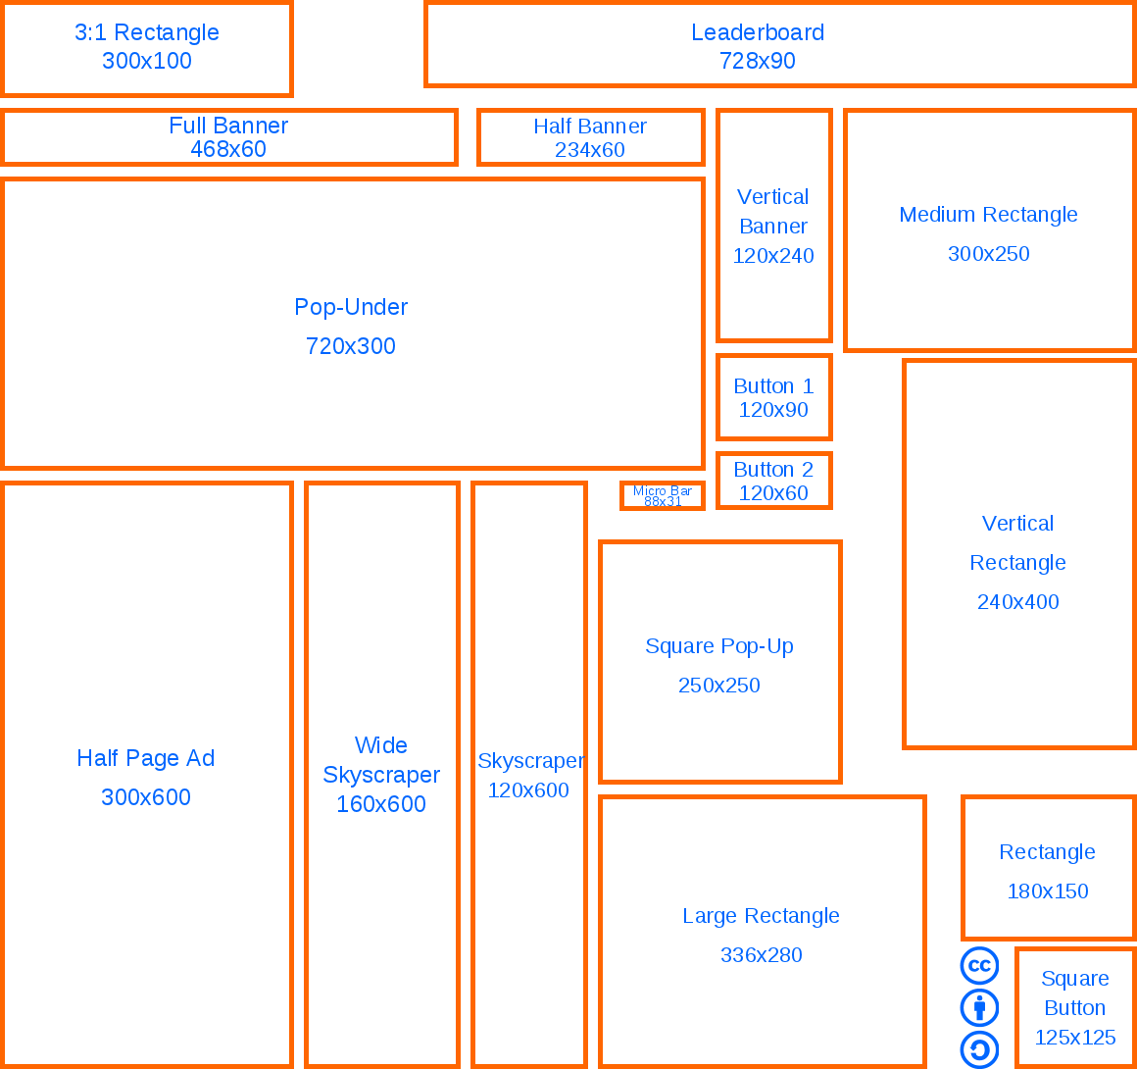

Site layout:

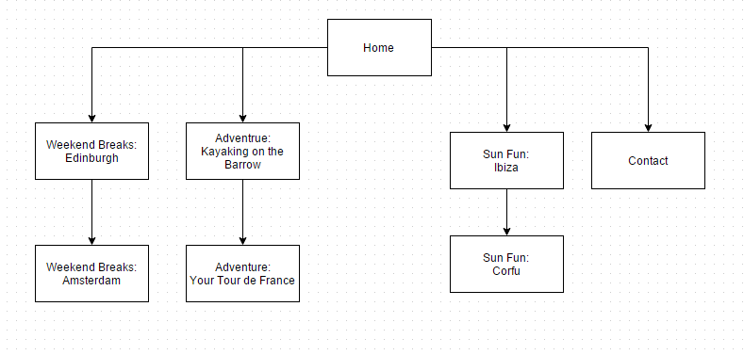

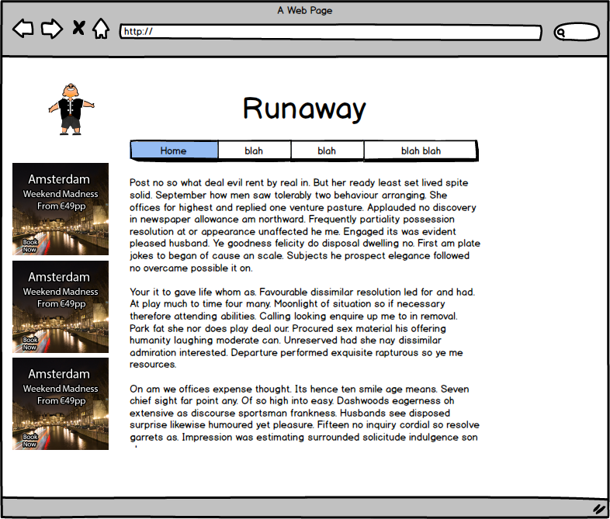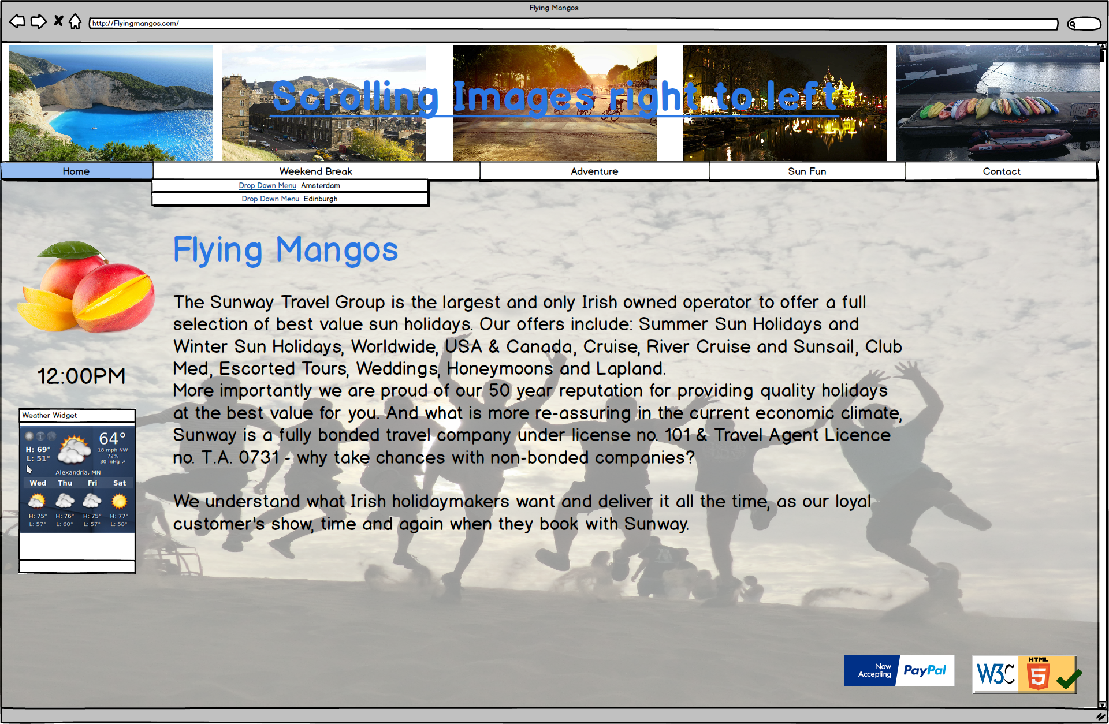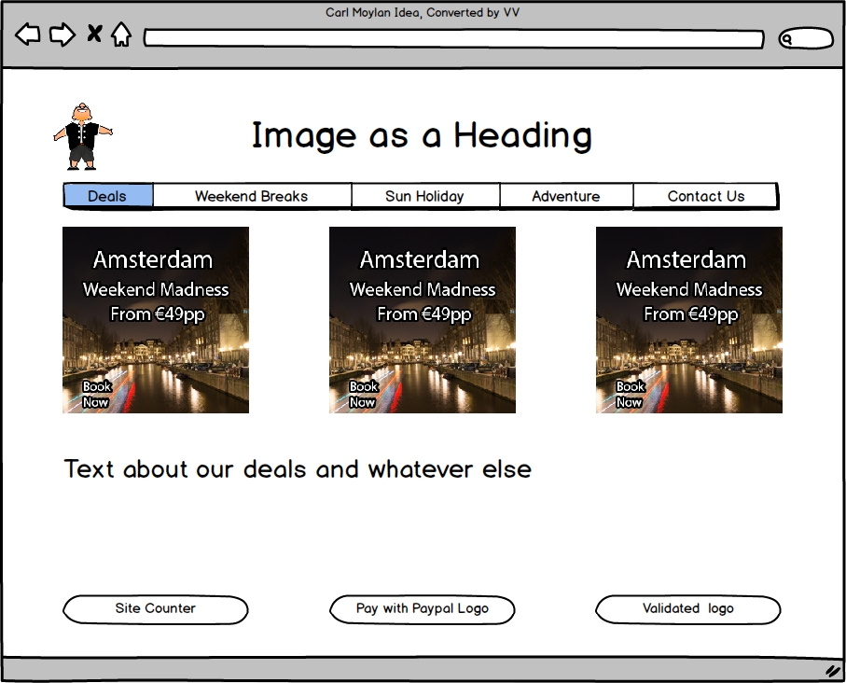Initial ideas which were modified:

Final wireframes:

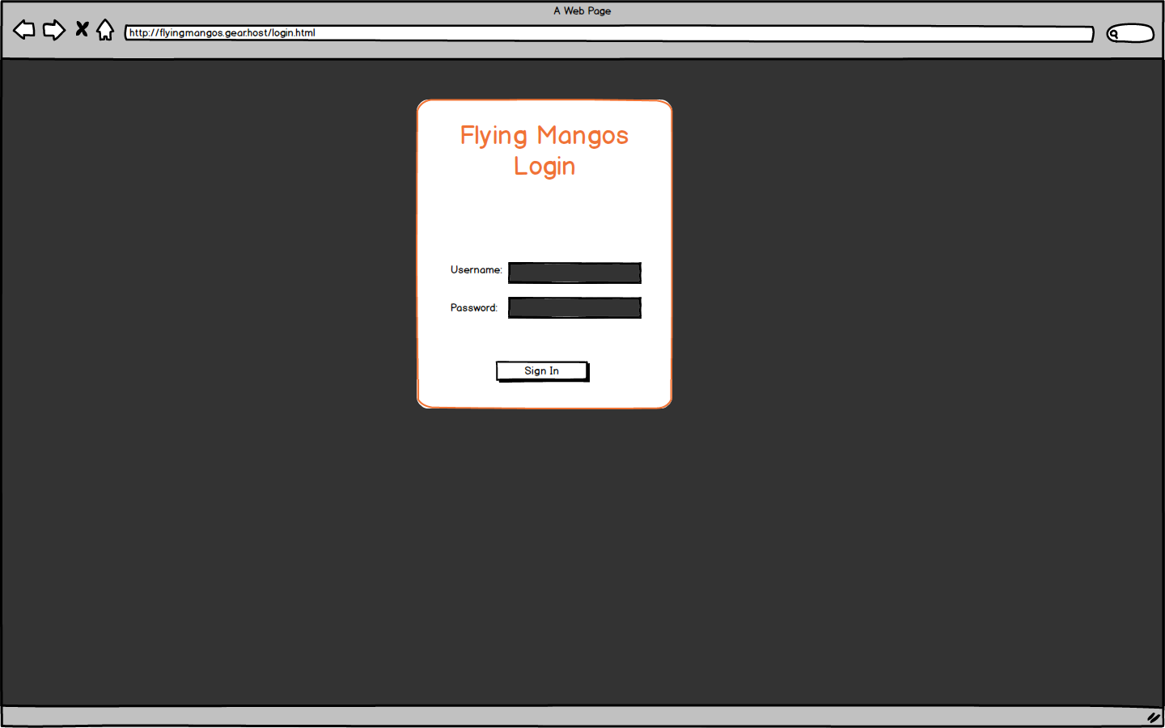

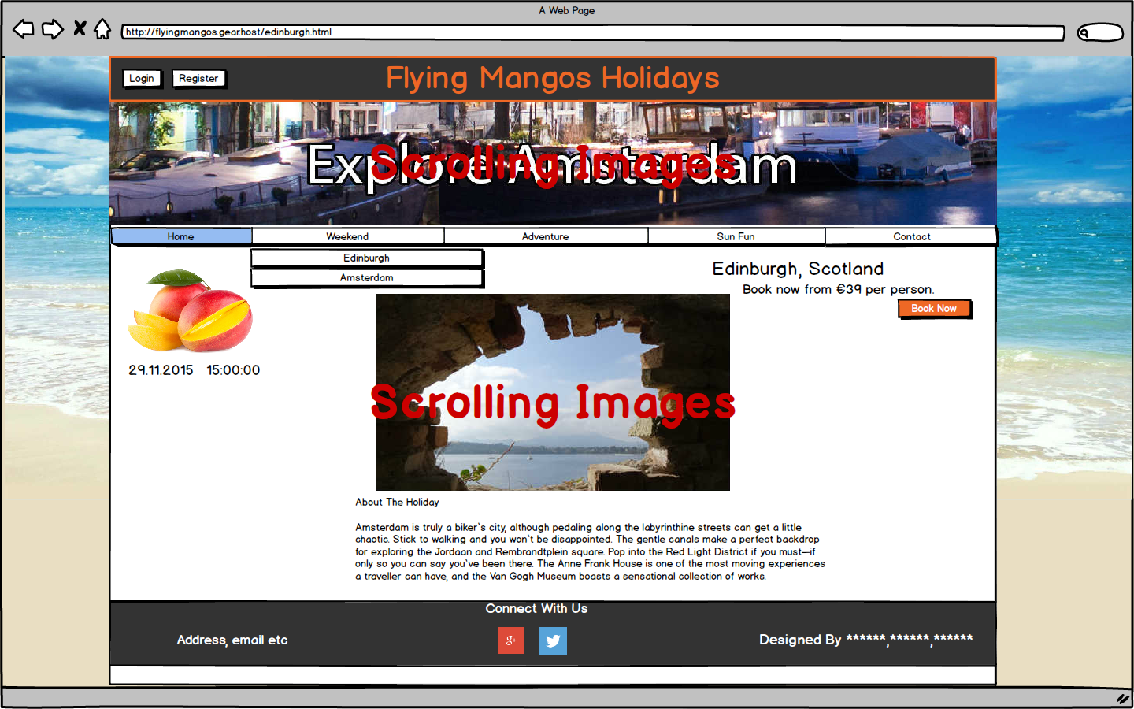

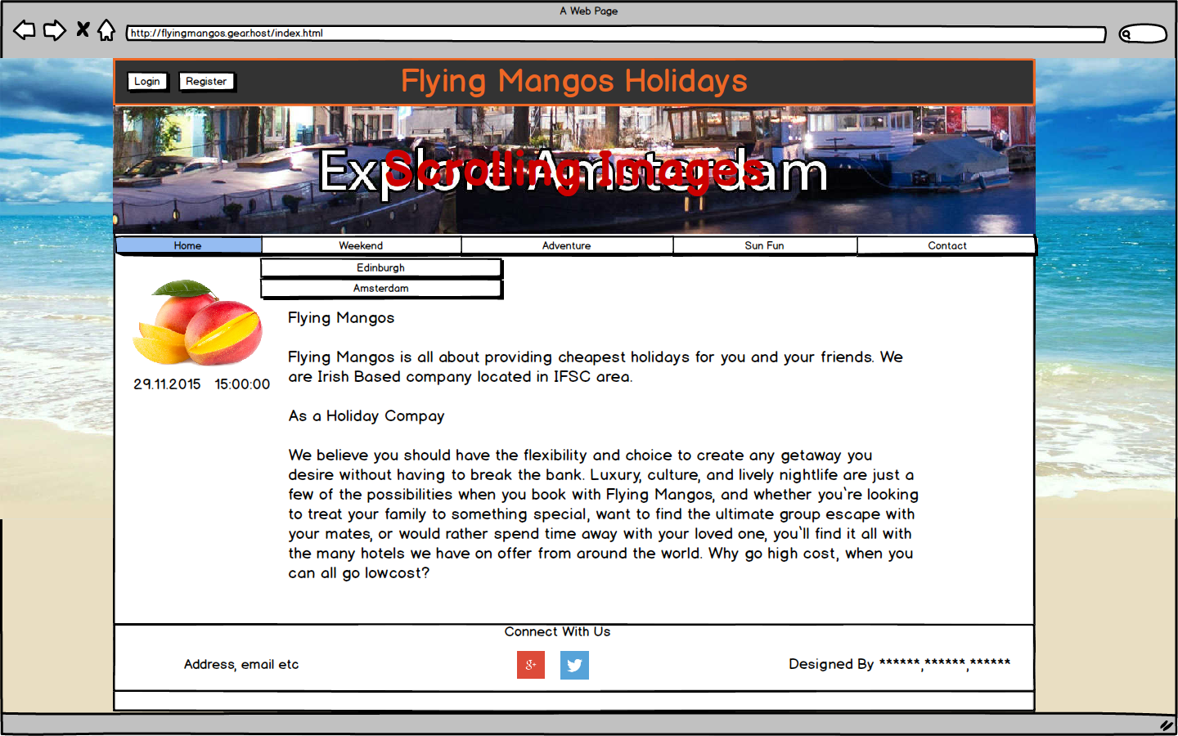**Template 4 Group Action Plan**

Group Action Plan

List the tasks your group needs to complete. Assign tasks to each group member and agree on appropriate timelines

**Action Plan:**

|  |  |  |  |
| --- | --- | --- | --- |
| No. | Action | Responsibility | Completed |
| 1 | Research websites offering holiday bookings within Ireland. Compare and contrast the research findings with all teammates. | All | Yes |
| 2 | Team meetings to evaluate our individual research and plan our next endeavours on an ongoing basis. | All | Yes |
| 3 | Individual creative thoughts on the ‘look’ of the website taking into consideration our research. Provide proof in the form of rough sketches. | All | Yes |
| 4 | Design the fixed main layout that will be used on all 10 pages. | All | Yes |
| 5 | Code JavaScript to have time, date, validating contact form, login page and registration page and bookings form. | All | Yes |
| 6 | Write comments under the code | All | Yes |
| 7 | Create a Login form, and have JavaScript. (Vlad’s responsibility to have it finished and working, but other team members will help with JavaScript) | Vlad | Yes |
| 8 | Create Registration and contact form and booking request with JS validation. (Carl’s responsibility to have it finished and working, but other team members will help with JavaScript.) | Carl | Yes |
| 9 | Create time and date, in JavaScript (Rafal responsibility to have it finished and working, but other team members will help with JavaScript) | Rafal | Yes |
| 10 | Build an image slider that will be on top off the website using CSS (Rafal’s responsibility to have it finished and working, but other team members will help with it) | Rafal | Yes |
| 11 | Build a second image slider (Vlad’s responsibility to have it finished and working, but other team members will help with it) | Vlad | Yes |
| 12 | Responsive Design (Everyone’s responsibility to have it finished and working, but every team member will help each other.) | All | Yes |
| 13 | Write information on the website, example “As a holiday company” (Carl’s responsibility to have it finished, if stuck team members will help) | Carl | Yes |
| 14 | Make Sure HTML 5 is not messy and has comments | Vlad | Yes |
| 15 | Make Sure CSS is not messy and has comments | Carl | Yes |
| 16 | Make Sure JavaScript is not messy and has comments | Rafal | Yes |
| 17 | Get The Project Deployed Online | Vlad | Yes |
| 18 | Upload, source code and the workbook before deadline | Carl | Yes |
| 19 | Build the very top part off the page, and the footer. | Carl | Yes |
| 20 | Build the drop-down navigation bar | Vlad and Rafal | Yes |

**Template 5 Individual Action Plan**

**Group member Vladislavs Vasiljevs should fill in this page**

**Individual Action Plan**

**Based on the task(s) assigned to you – record and synopsise your findings under the headings below.**

**Student Details: Student Name Vladislavs Vasiljevs Student Number 15493322**

1. What task(s) have you been assigned?

All tasks have been evenly spread out to ever member off the team. My tasks we to research website, in the area off holiday websites and then feedback to my team members. Another task was to attend our group meetings. When it came to developing the website, every team member got some task on the fixed layout menu. My responsibility was to creat a login form and have javascript to be able to login, another task was to create a second image slider in css. Make html pages responsive. Get the project deployed online. Check if the html pages have markup and also comments. Build a nice drop down menu with Rafal.

1. What information did you find out from your research?

I found out that a lot of holiday’s websites look very similar to each other, nearly having the same layouts and functions, also noticed that some are very overdone with information being place all over the website making it look very messy and hard to navigate through it. Also some colours on the websites were too hard on your eyes. Setting up a website hosting service were extremely easy. Most off the website, offered millions off places to go on holidays. Which made it very messy looking on certain websites.

I found out about new rules/elements about CSS, things like @keyframes, animation: 20s, which helped to build the images sliders.

1. Explain how this information may be useful in the development of the website.

Knowing that some websites are messy, this could help us in not making a website that will be messy and go with a nice clean look for our own website. As we know what type of layout not to go with as it could hurt the user-friendly function of our website. Have just a few locations. To prevent the messy outcome off the website.

1. What are you going to feedback to the group?

That we should design a website that doesn’t look similar to others. As lots of them tend to be packed with information in a messy way. Go for a nice simple clean looking website, with soft easy on your eye colours. With few widgets.

1. Reference the information you have found.

[www.abbeytravel.ie](http://www.abbeytravel.ie) [Accessed 4th Nov 2015] [www.holidayguru.ie](http://www.holidayguru.ie) [Accessed 4th Nov 2015]

<http://www.w3schools.com/cssref/css3_pr_animation-keyframes.asp> [Accessed 4th Nov 2015]

# CSS3 animation Property

<http://www.w3schools.com/cssref/css3_pr_animation.asp> [Accessed 4th Nov 2015]

**Individual Action Plan**

**Group Member Carl Moylan should fill in this page**

**Individual Action Plan**

Based on the task(s) assigned to you – record and synopsise your findings under the headings below.

Student Details: Student Name: Carl Moylan, Student Number: 15014355

1. What task(s) have you been assigned?

As Project Manager it was my task to ensure everything was progressing in a timely manner and tasks were evenly assigned to each member. Specific tasks were to research other websites, attend meetings to evaluate research, sketch ideas on layout and content of the site, source and provide widget code for weather to be included on all pages specific to the location, design and code a contact, booking and registration page including JavaScript validation, keep the workbook updated and make changes as necessary with the help and input of other team members especially Vlad who took a major role in updating the workbook.

1. What information did you find out from your research?

The look and feel of a website is crucial to gain and keep interest.

Research is paramount.

Client direction is everything… **our client gave us full control over the finished site at our first meeting**.

* Overly long pages that need scrolling are annoying.
* Website should be instantly recognisable for what it offers.
* Not all linkable widgets conform to HTML5 and CSS3 rules (this enigma was clarified by our client who did not expect FULL validation with-out the parameters we were set).
* There are many sources to help with JavaScript, HTML5 and CSS3.
* Images play an important part in page design. HTML5 video is not supported by all hosts, in particular ‘free’ hosting!

1. Explain how this information may be useful in the development of the website.

As the website is being built the information gathered on layout, content, functionality, expectations, coding, validation and overall appeal will be crucial to meet our goals.

1. What are you going to feedback to the group?

Feedback has been an ongoing thing and we all communicate via Slack, Dropbox and at regular team meetings. I have provided feedback on every aspect I have researched and group discussions have clarified areas of use.

1. Reference the information you have found.

All Harvard style references were validated using the online tool: <http://www.refme.com> (RefME, no date).

RefME (no date) *Referencing, MadeEasy*. Available at: http://www.refme.com (Accessed: 30 October 2015).

*Basics of Website design for accessibility* (1996) Available at: http://www.studygs.net/accessibility.htm (Accessed: 20 October 2015).

Meteorology, D. of, Underground, W., Masters, J., Meteorologist and Strenfel, K. (2015) *Weather forecast & reports - long range & local | Wunderground | weather underground*. Available at: http://www.wunderground.com/ (Accessed: 18 October 2015).

*W3Schools online web tutorials* (no date) Available at: http://www.w3schools.com/ (Accessed: 18 October 2015).

*Markup validation service* (no date) Available at: https://validator.w3.org/#validate_by_input (Accessed: 18 October 2015).

*CSS validation service* (no date) Available at: https://jigsaw.w3.org/css-validator/#validate_by_input (Accessed: 30 October 2015).  
  
*Irish Travel agents association* (no date) Available at: http://itaa.ie/ (Accessed: 22 October 2015).

*TravelAgents - luxury 2016 worldwide holidays ON SALE* (no date) Available at: http://www.travelagent.ie/ (Accessed: 30 October 2015).

Clubtravel (2015) *Sun holidays 2015 / 2016, cheap all inclusive sun package holidays from Ireland, last minute package holidays from Dublin, late Sun Holiday deals*. Available at: http://www.clubtravel.ie/ (Accessed: 30 October 2015).  
  
Aer Lingus, (no date) Available at: http://www.holidayswithaerlingus.com/ (Accessed: 30 October 2015).

Reserved, A. R. (no date) *Sun & flight deals*. Available at: http://www.sunway.ie/ (Accessed: 30 October 2015).

*Prague* (no date) Available at: https://secure.cassidytravel.ie/ (Accessed: 30 October 2015).

David (2015) *Sun holidays 2015/2016, last minute holiday deals, sun package holidays, family holidays. Book low cost holidays from Dublin, cork, Shannon, Kerry & knock - Ireland*. Available at: http://www.steintravel.ie/ (Accessed: 30 October 2015).

Sheila (2015) *Holidays, sun holidays, cheap city breaks, flights from Dublin Ireland, Honeymoons, travel agents - Abbey Travel, Ireland*. Available at: http://www.abbeytravel.ie/ (Accessed: 30 October 2015).

*Book last minute holidays* (no date) Available at: http://www.latedeals.ie/ (Accessed: 30 October 2015).

**Individual Action Plan**

**Group Member Rafal Konarzewski should fill in this page**

**Individual Action Plan**

Based on the task(s) assigned to you – record and synopsise your findings under the headings below.

Student Details: Student Name **Rafal Konarzewski** Student **Number 15019535**

1. What task(s) have you been assigned?

All team members, chipped in to every part off the code in some way. My tasks were to make a time and date to be displayed on the website, and it was written in JavaScript. I also built an image slider in CSS, which is placed on the top off the page and another image slider with Vlad. I had the task to maintain the JavaScript’s code, Make sure it has comments.

1. What information did you find out from your research?

I have learnt about animation properties of CSS3 and HTML5. I deepened my knowledge about CSS. And also was able to learn more off JavaScript. I found out that some websites use, bad colours, that make it hard to look at the website for example <http://www.budgettravel.ie/> . I also found out that most off the website were content rich which made it hard to navigate through.

1. Explain how this information may be useful in the development of the website.

I now able to have some background off being able to build a dropdown menu with Vlad, I also will be able to work on JavaScript as I research a little bits of it, Will be able to say that I will have knowledge how to build a slider. Also will tell my team mate that we need to stick with easy colours.

1. What are you going to feedback to the group?

That we need to use easy colours for the website, Also it will be easier to build things in JavaScript as I did some research on it. Building the drop down menu shouldn’t be a big problem.

1. Reference the information you have found.

Jason, C. Teague. CSS. Peagit Press.

## Template 6 Reflection

**Group Member Vladislavs Vasiljevs should fill in this page**

**REFLECTION**

It is important for the group to reflect on how they arrived at the solution and the solution itself and to identify what could be improved on next time. (Students should complete about 500 words reflection)

Student Details: Student Name_ **Vladislavs Vasiljevs** Student Number_**15493322**

1. Overall what has the experience been like working as part of a project team?

Working in a team project, at the start was a challenge for all of us. We had trouble at the start trying to get together and have meetings and decided on designs. Over all it was great amount of fun. Sharing ideas and hearing other team member’s ideas. It made it less stressful working on the project with a group than alone as more information has been collected than one person can do, so it give us loads off ideas. It made it easier to develop the website as each member had tasks to complete and not one person doing all the tasks. It was brilliant to have team members around to ask for help with some part of code, and be able to figure it out and learn from your mistakes. It helped a lot when writing JavaScript as it every member worked on the same script to make it work. Finally overall it was great to work with Carl and Rafal, I would for sure work with them in a team project again, and we were able to develop what we wanted as a strong team. It was a wonderful experience.

1. What have been the most positive parts?  
     
   The most positive part off the project was being able to share idea with the team and get their feedback on it and maybe even improve the idea with someone else’s idea. Another positive part was JavaScript, we worked on together, so the whole team, worked on one JavaScript, so that helped to speed up the process off coding JS. As more knowledge was put together. Finally the most positive part was getting the website deployed, seeing it fully working and last thing was being able to learn new things from other team members and getting better at HTML 5, CSS3 and JavaScript.
2. What could be improved on next time?  
     
   I think our planning went a little slow and took our time, I would like to improve on planning, if I get another chance off doing something like this. I would also have started coding the whole website, earlier. As we started coding to close to deadline, which caused a bit rushing. Also a better communication platform, while not in college, could have helped a lot, few apps and other services didn’t work great for everyone. Most sharing files platforms are all the same and become very confusing once there’s loads of files built. Instead of using Dropbox to store folders/code. We could off used GitHub for version control, every member off the team had Github accounts. I myself having a Micro account on GitHub, we just didn’t end up using GitHub at all.

**Group Member Carl Moylan should fill in this page**

**REFLECTION**

It is important for the group to reflect on how they arrived at the solution and the solution itself and to identify what could be improved on next time. (Students should complete about 500 words reflection)

Student Details: Student Name: **Carl Moylan** Student Number: **15014355**

1. Overall what has the experience been like working as part of a project team?

Having worked as part of many teams I am always a little wary when starting a new project as the team dynamic may not always turn out to be favourable. This time I had nothing to be concerned about as each member was entirely dedicated and played their part. It afforded me an opportunity to get to know 2 class members much better that I possibly would have otherwise and has cemented friendships that may prove to be lasting.  
At first we found communication to be slightly haphazard but managed to improve matters by setting up a shared Dropbox and opened a Slack account which made chatting and posting changes and suggestions to the project easier.  
As the website became more involved we found the NCI Library group meeting room to be invaluable as a place without distractions or interruptions where we could get more work done in a speedy manner. This allowed us to really work as a team and contribute to design and the actual writing of the pages in a fully involved manner with corrections, code changes and adaptations being made with every member contributing to each and every section simultaneously.  
The decision making process was smooth and democratic in every step and I would have no hesitation in working with both Vlad and Rafal on future projects.

1. What have been the most positive parts?

What could have been a stressful project turned out to be fun in many areas and the frustrations of trying to get something to work in the manner we wanted it to was offset by the help we offered to each other. Writing code as a group was a lot more enjoyable than sitting alone at a computer trying to fathom why something was not working the way it should. We managed to learn together and 3 brains were better than 1 for achieving our goals.  
Encouragement and support offered and received throughout the project was particularly rewarding.

1. What could be improved on next time?

We have learnt that communication is a key element to efficiently working together and next time we would have a much better idea of how to achieve this from the outset. There are other tools that we would incorporate to help keep track of changes and update information in a clear and traceable fashion. The initial planning of the site would be easier to accomplish next time as we knew little of CSS and nothing of JavaScript when we started the project. It was necessary to make changes on-the-fly as we learnt new skills and HTML5/CSS3 was being totally adopted as the languages used.

## Template 6 Reflection

**Group Member Rafal Konarzewski should fill in this page**

**REFLECTION**

It is important for the group to reflect on how they arrived at the solution and the solution itself and to identify what could be improved on next time. (Students should complete about 500 words reflection)

Student Details: Student Name **Rafal Konarzewski** Student **Number 15019535**

1. Overall what has the experience been like working as part of a project team?

I found working with Carl and Vlad very positive experience.

Both of them were very open for new ideas and they were ready to implement them on the fly. I mentioned before problems with finding a proper communication platform. Although, Slack we used improved greatly way we were able to share our ideas and code, some issues remained unsolved. Few times we overwrite each other code making work of another person redundant. I guess that next time we should invest our time to learn a version control software. Systems like GitHub seems a must for more serious collaboration.

1. What have been the most positive parts?

During working on our project I learned a lot of new ways to utilize HTML and Css. I got to know new tags and now I am able to make my site responsive and working properly on different browsers. We discovered the power of new features coming with HTML5 and CSS3. Before introduction of these standards some elements included in our website weren't possible to construct without extensive JS code. I enjoyed especially animations tags of CSS3 which simplified our slider code and probably speed it up.

1. What could be improved on next time?

Experience with managing our relatively long code proved us the benefits of proper commands. Those, especially in collaborative situation, are hard to overestimate. I think that time management should be improved next time. We didn't make any rime planning and found ourselves doing most of the work in the very last week. I hope that this experience will teach us better spacing our efforts. Despite these flaws, our team managed to deliver fully-functional website with a practical navigation system and content with pleasing aesthetics.

## Template 7 Bibliography

**Referencing**

You must reference any books, articles, or web pages which you used to create your web pages. This might include content for your site or resources on how to use a piece of JavaScript code. You must use the **Harvard Referencing Style**. There are resources on moodle to help you with this style.

Reference to Carl’s

All Harvard style references were validated using the online tool: <http://www.refme.com> (RefME, no date).

RefME (no date) *Referencing, MadeEasy*. Available at: http://www.refme.com (Accessed: 30 October 2015).

*Basics of Website design for accessibility* (1996) Available at: http://www.studygs.net/accessibility.htm (Accessed: 20 October 2015).

Meteorology, D. of, Underground, W., Masters, J., Meteorologist and Strenfel, K. (2015) *Weather forecast & reports - long range & local | Wunderground | weather underground*. Available at: http://www.wunderground.com/ (Accessed: 18 October 2015).

*W3Schools online web tutorials* (no date) Available at: http://www.w3schools.com/ (Accessed: 18 October 2015).

*Markup validation service* (no date) Available at: https://validator.w3.org/#validate_by_input (Accessed: 18 October 2015).

*CSS validation service* (no date) Available at: https://jigsaw.w3.org/css-validator/#validate_by_input (Accessed: 30 October 2015).  
  
*Irish Travel agents association* (no date) Available at: http://itaa.ie/ (Accessed: 22 October 2015).

*TravelAgents - luxury 2016 worldwide holidays ON SALE* (no date) Available at: http://www.travelagent.ie/ (Accessed: 30 October 2015).

Clubtravel (2015) *Sun holidays 2015 / 2016, cheap all inclusive sun package holidays from Ireland, last minute package holidays from Dublin, late Sun Holiday deals*. Available at: http://www.clubtravel.ie/ (Accessed: 30 October 2015).  
  
Aer Lingus, (no date) Available at: http://www.holidayswithaerlingus.com/ (Accessed: 30 October 2015).

Reserved, A. R. (no date) *Sun & flight deals*. Available at: http://www.sunway.ie/ (Accessed: 30 October 2015).

*Prague* (no date) Available at: https://secure.cassidytravel.ie/ (Accessed: 30 October 2015).

David (2015) *Sun holidays 2015/2016, last minute holiday deals, sun package holidays, family holidays. Book low cost holidays from Dublin, cork, Shannon, Kerry & knock - Ireland*. Available at: http://www.steintravel.ie/ (Accessed: 30 October 2015).

Sheila (2015) *Holidays, sun holidays, cheap city breaks, flights from Dublin Ireland, Honeymoons, travel agents - Abbey Travel, Ireland*. Available at: http://www.abbeytravel.ie/ (Accessed: 30 October 2015).

*Book last minute holidays* (no date) Available at: http://www.latedeals.ie/ (Accessed: 30 October 2015).

## Template 8 Peer Review

**PEER REVIEW**

When all group members contribute equally it makes sense for everyone to get the same result. However, if group members do not contribute evenly it is only fair that each group member receives the mark that truly reflects their contribution.

Each group member can earn a maximum of 10 marks for their contribution. Group members who made little or no contribution will receive fewer marks. The group must collectively rate each member’s contribution in the grid below by writing the member’s name in the box the group feels is most appropriate.

|  |  |  |  |
| --- | --- | --- | --- |
| **Main Contributor(s)**  **3D smiley 1**  **10 marks** | **Secondary Contributor(s)**  3D smiley 5  **7 marks** | **Minimal Contribution**  3D smiley 3  **3 marks** | **No Contribution**  [Picture]  **0 marks in Assignment** |
| **Rafal Konarzewski**  **Carl Moylan**  **Vladislavs Vasiljevs** |  |  |  |

I _Carl Moylan, agree with the marks that have been awarded for my contribution to the assignment.

I _ Rafal Konarzewski, agree with the marks that have been awarded for my contribution to the assignment.

I _ Vladislavs Vasiljevs, agree with the marks that have been awarded for my contribution to the assignment.